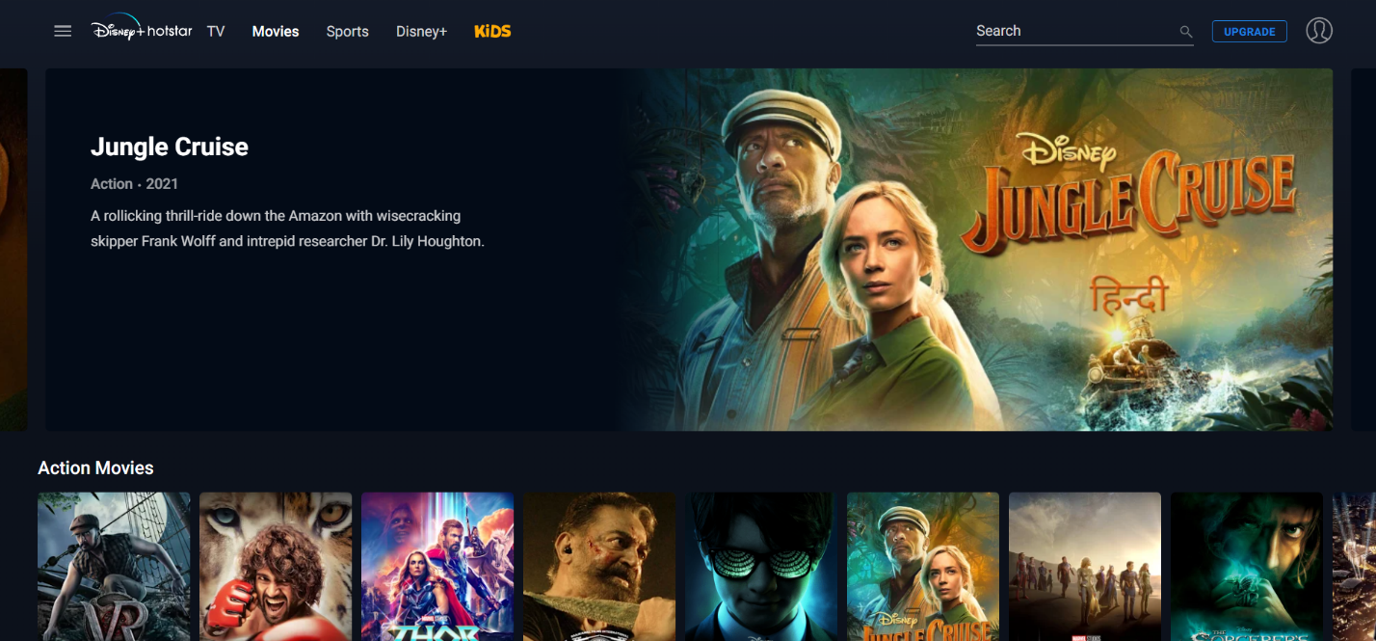

**Project Name: Clone of Disney+ Hotstar**

**About Disney+ Hotstar:**

Disney+ Hotstar is India's largest premium streaming platform. As earlier their name was Hotstar. It was officially launched by Star India on 11 February 2015. It’s a subscription-based OTT video streaming platform. Also, be streaming Live Crickets Matches and a digital TV network. We can subscribe to their plan to enjoy their content.

**Features of Project :**

1. Login and Signup Page
2. Profile Page
3. Subscription and Plane page
4. Payment Gateway page
5. Category Wise Page
6. Separate Page for Kids
7. Streaming page

**Technology Used:**

**Front-End:**

1. Html
2. Css
3. Bootstrap
4. React

**Back-End:**

1. Node js
2. Express js

**Database:**

1. MongoDB

**Coding Environment:**

1. Visual Studio code

2. Git bash

3. Git hub

4. Node js.

**Submitted by-**

**Sakil Rohman ( Batch 67)**